The grade I think I deserve is 8.5. I worked mostly on the receptory “Friday” (even though the license and the .ditignore are in a receptory called “things”. Apart from the usual things as change my profile and the things you proposed, I explored a bit more and created an organization and a team inside it. I also started creating a wiki and added some links in the text. In the following lines you can see a summarize of what I did. Home you like it

Contenido

Create a repository, clone it modify push and pull 2

Create a pull request 4

Collaborate and get data that is been removed back 6

Change profile and follow other people and star a project 7

Issue on a project I am not collaborating 7

Fork a receptory I am not collaborating 8

Create a repository in an organization 9

Create a team in an organization and invite new members 9

Create a wiki with two pages and a link between the pages (as in real Wikipedia) 9

Create a to do list in the issues 10

Create a depository with a license and .gitignore 11

Close issue 12

**e índice.**

# Create a repository, clone it modify push and pull

After installing git and creating an account on github I am going to create a repository.

1. Click on new in the repository

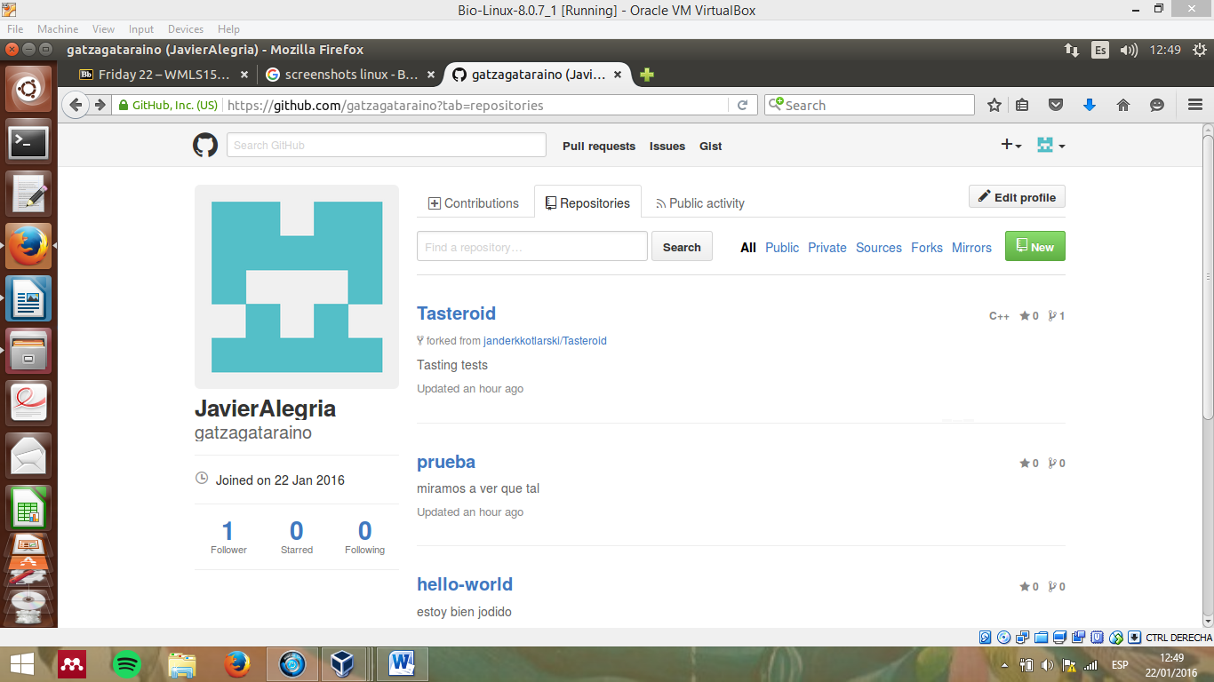

1. After that, this screen will show up. I have to fill the data (put a name, etc.) I will also create a ReadMe.

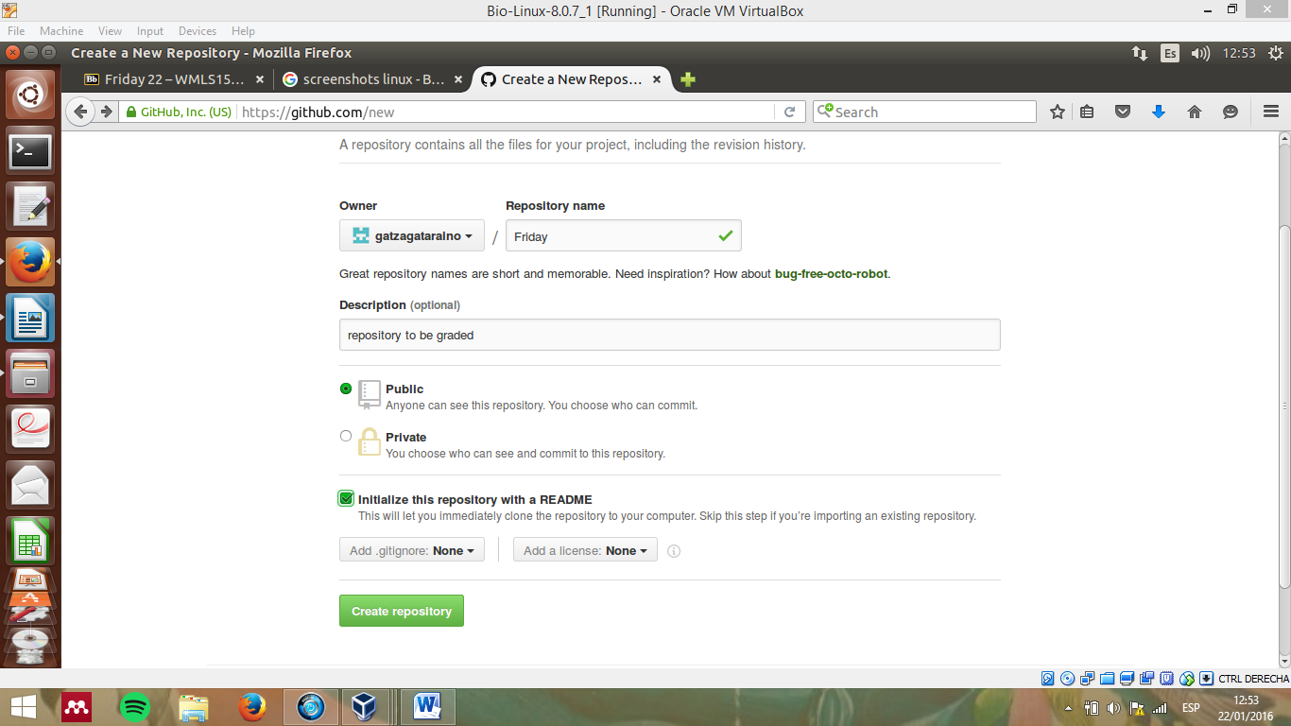

1. We create the repository and…

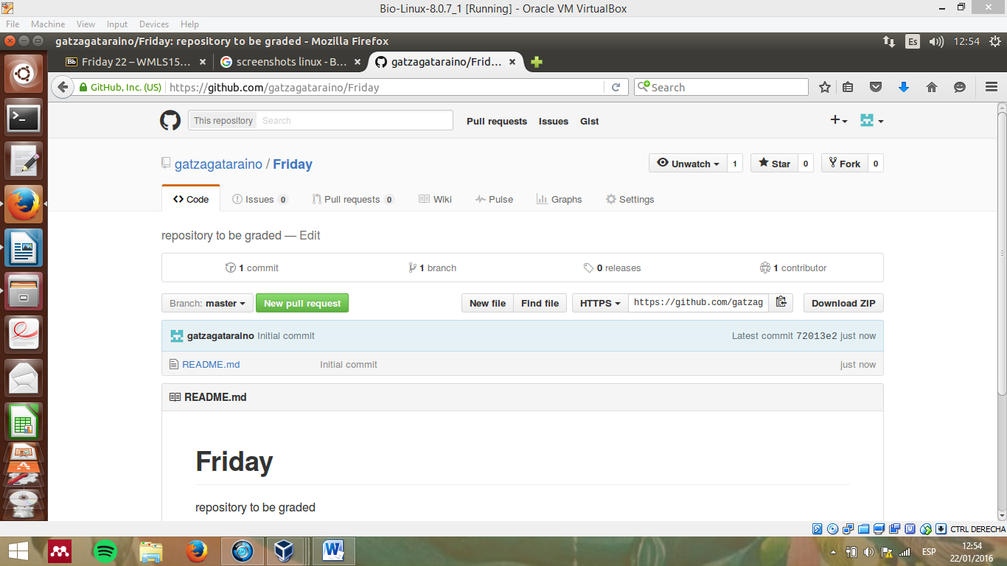

1. Now we go to the terminal and we are going to clone it into our home directory to make some modifications and add an image. For doing that we press fork , we copy the address and write the following on our terminal:

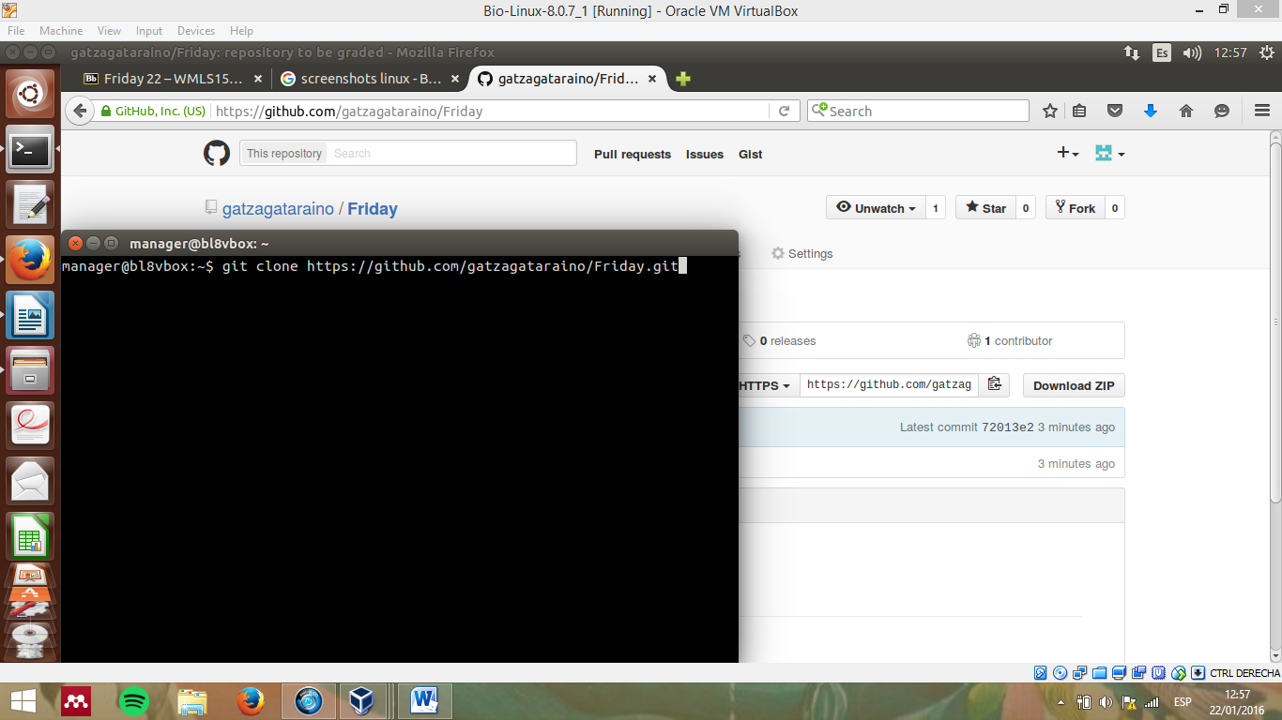

1. After pressing enter we will find a folder called Friday on our home directory. I am going to modificate the text file and add an image to it. After that I go to the terminal and by typing the following commands I upload my repository to github: (add –all :/, commit –m and push):

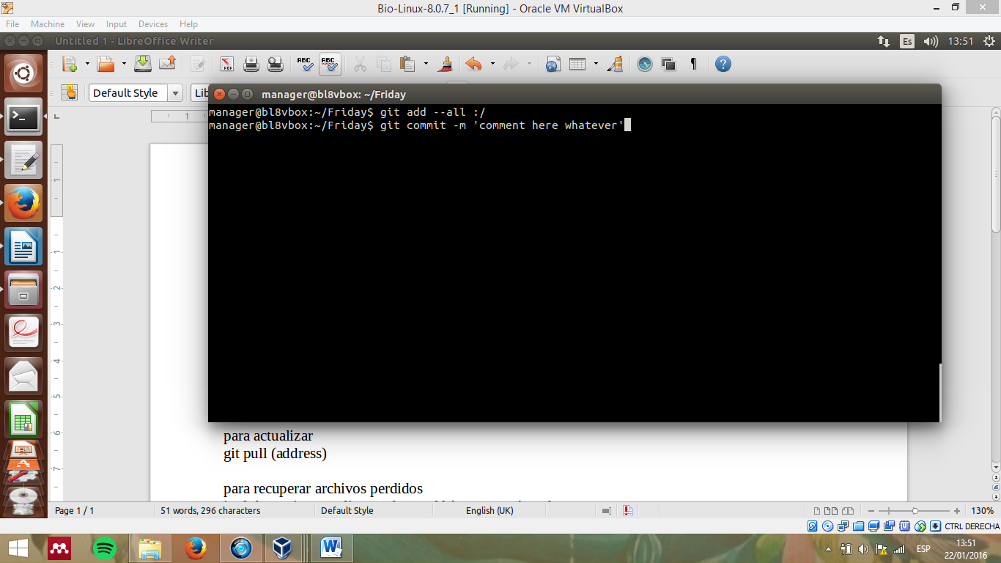

(after pressing intro in the terminal I write git push, write my profile name and password and the process will be finished)

1. Now if I modify the data online (or somebody else does) I have to update my files by typing git pull in the terminal from the Friday folder.

# Create a pull request

1. I look for a profile and check her repositories (in this case is a classmate called Miranka). I click on one repository and following the steps previously presented I download her repository and modify it and I push it back to github.
2. After that I press create a pull request
3. Github will compare our folders and when see that merging is possible, I leave a comment

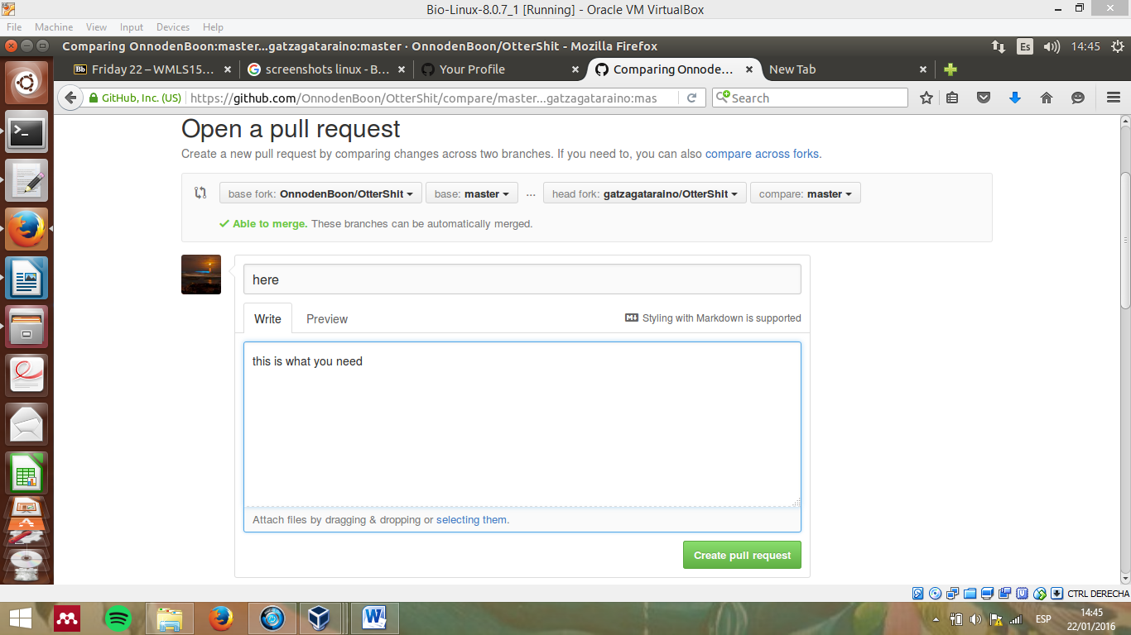

1. As you can see, he liked my pull request and accepted it

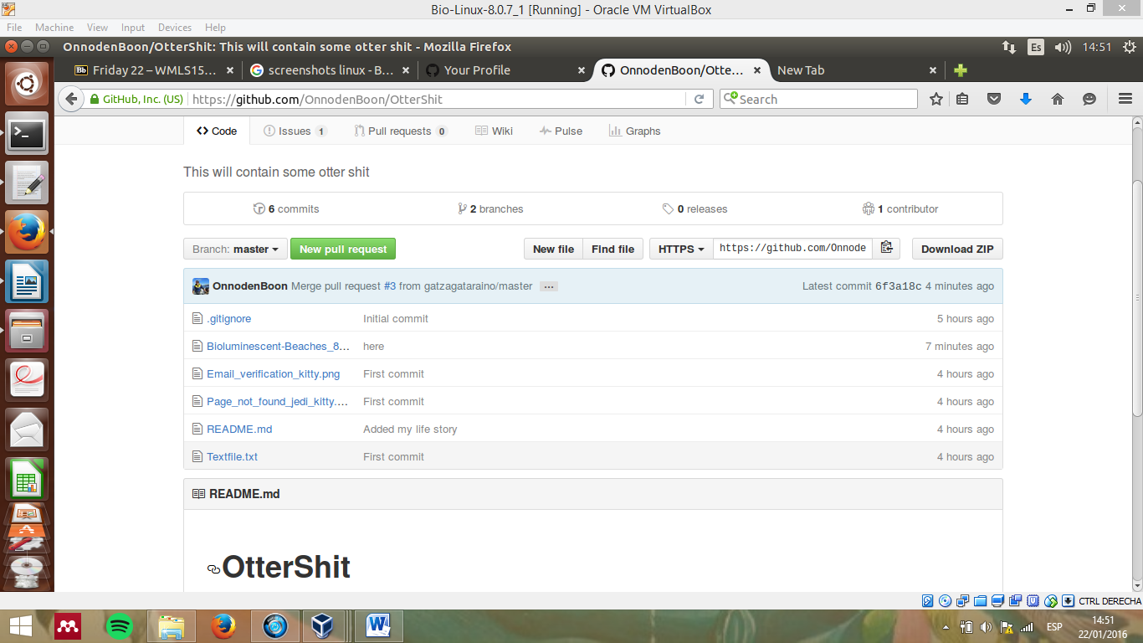

# Collaborate and get data that is been removed back

1. I am going to collaborate with Miranka on my Friday repository. By doing that she will have full access and capacity for modifications of this repository.

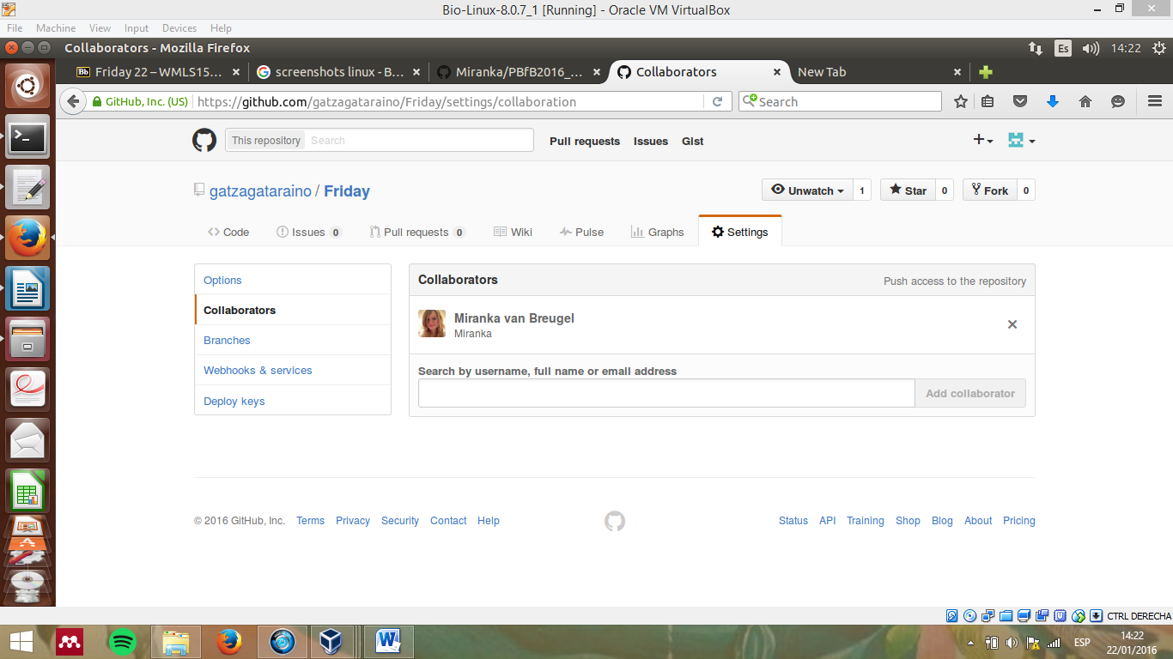

1. If she removes something that I wanted, don’t worry! Github saves everything and any file can be recovered by pressing <>code 🡪 commits. There you find all the modifications made, and you can get the repository as it was before any modification.

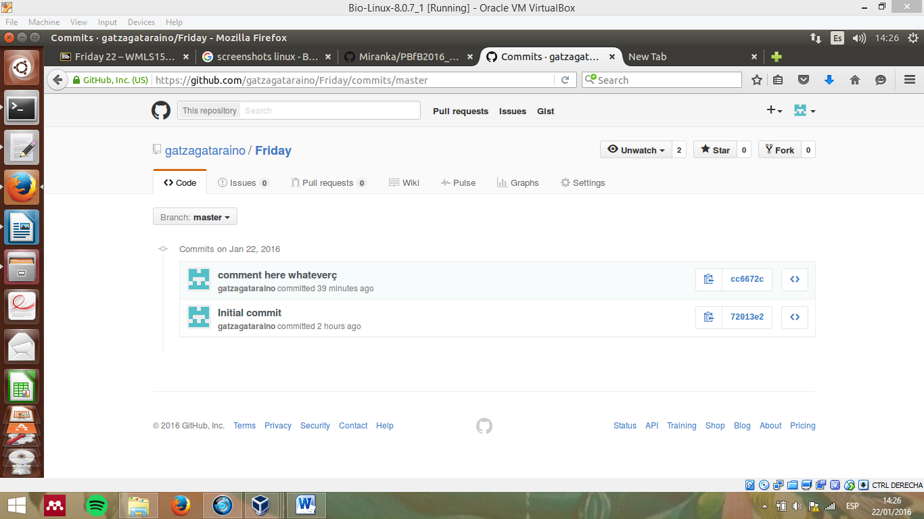

# Change profile and follow other people and star a project

I have changed my profile picture, name and show my e-mail. Also, I have one follower and I am following other person. I also starred a project.

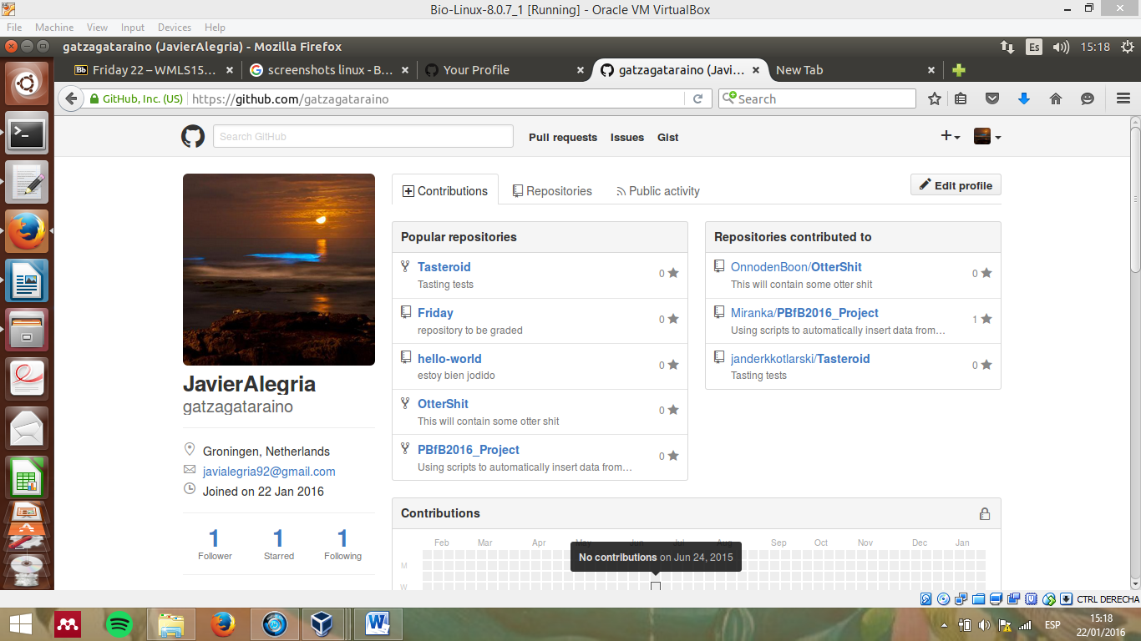

# Issue on a project I am not collaborating

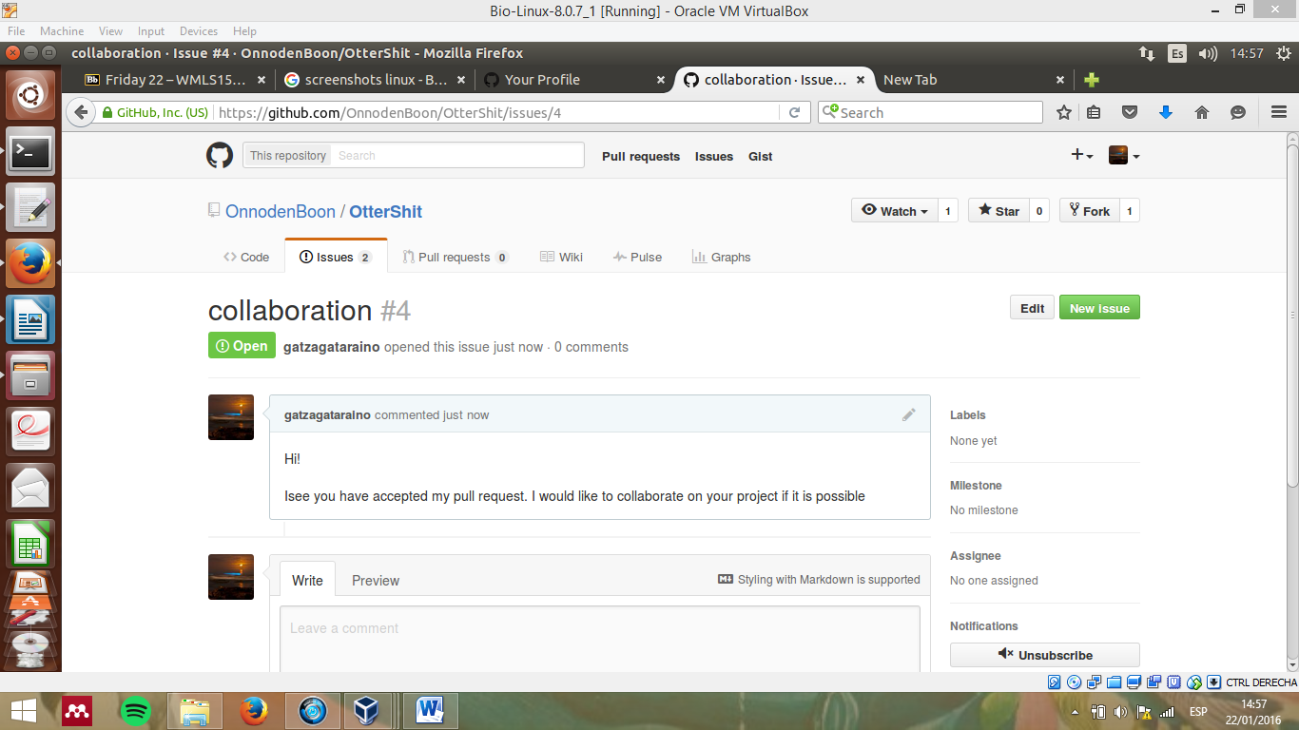

# Fork a receptory I am not collaborating

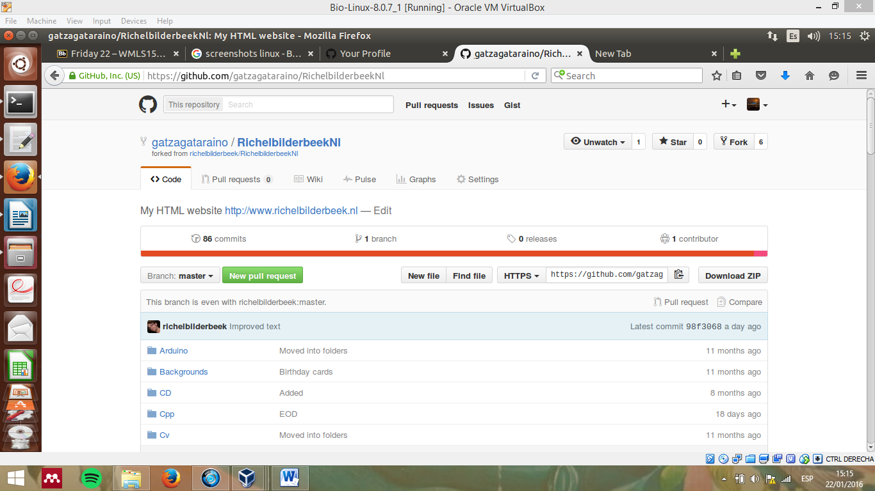

Create an organization

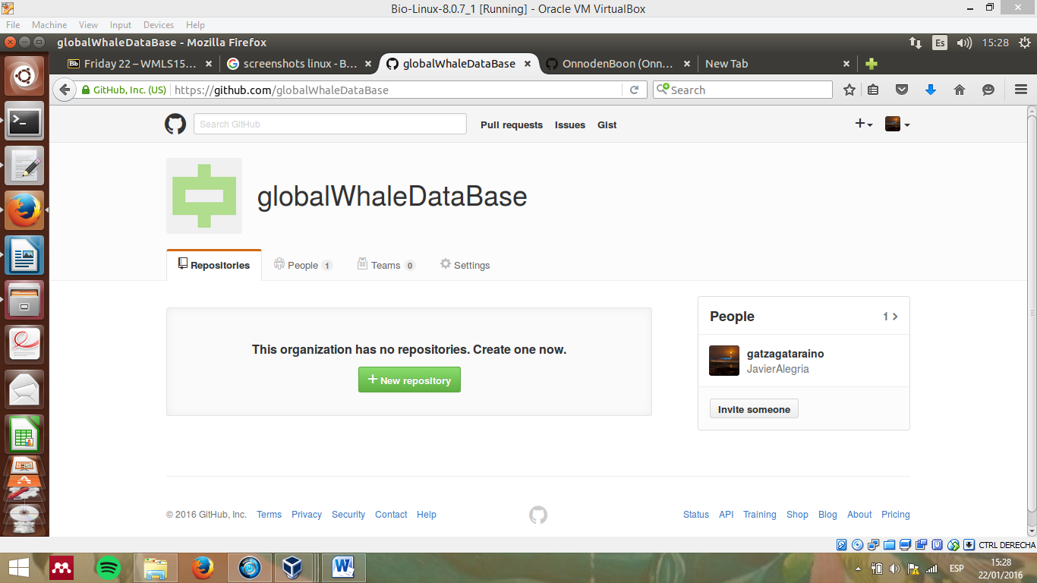

# Create a repository in an organization

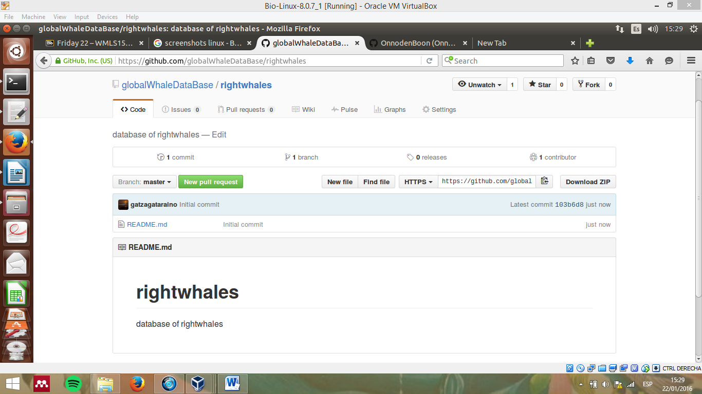

# Create a team in an organization and invite new members

This is a good way to subdivide the organization and work by teams coding together

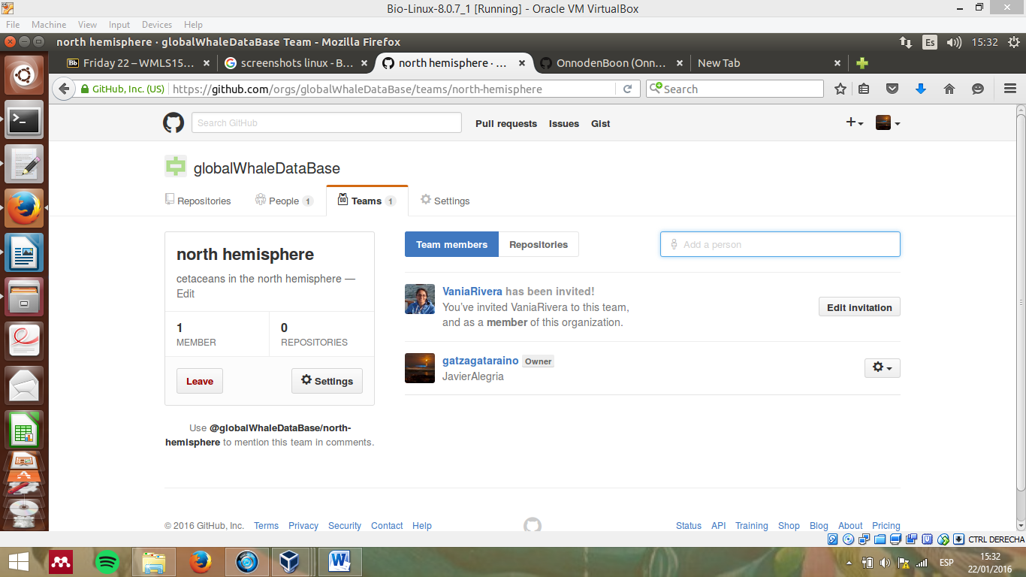

# Create a wiki with two pages and a link between the pages (as in real Wikipedia)

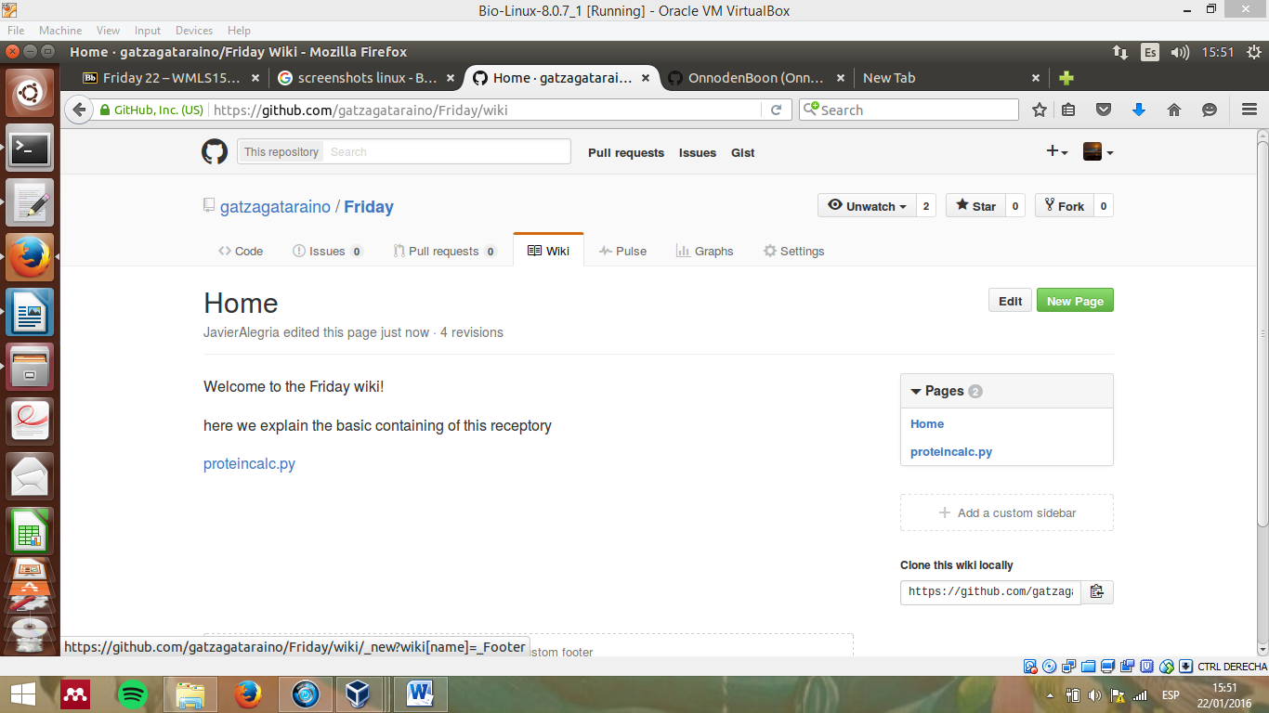

# Create a to do list in the issues

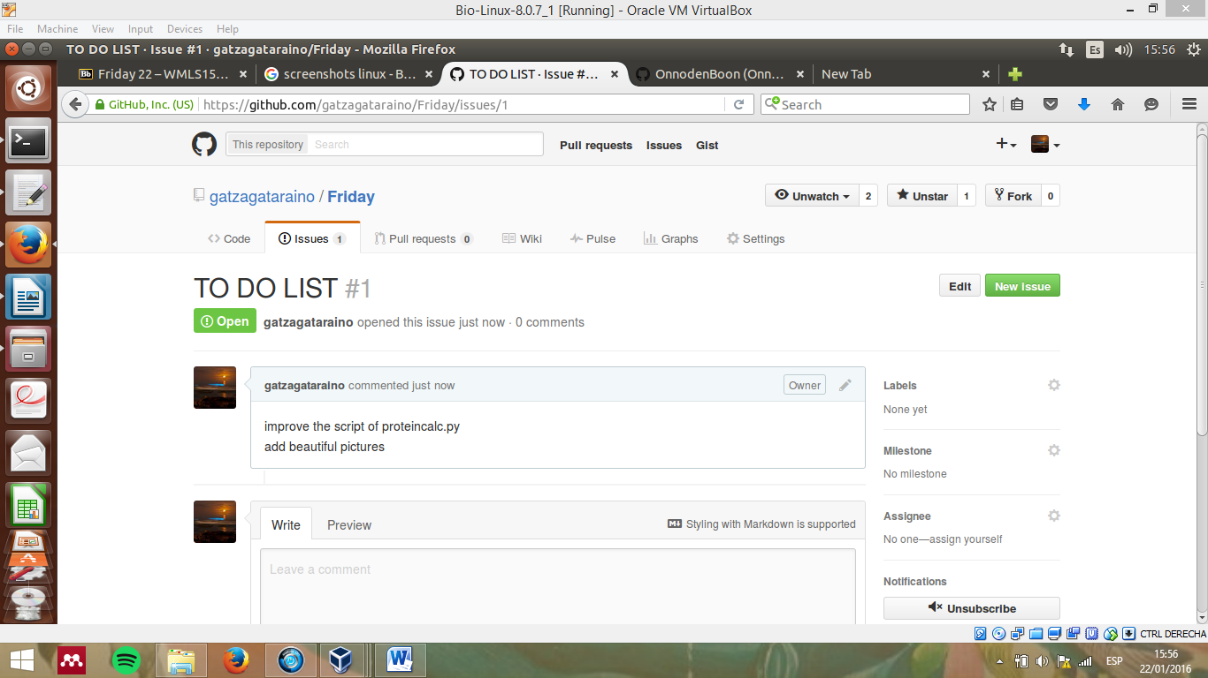

# Create a depository with a license and .gitignore

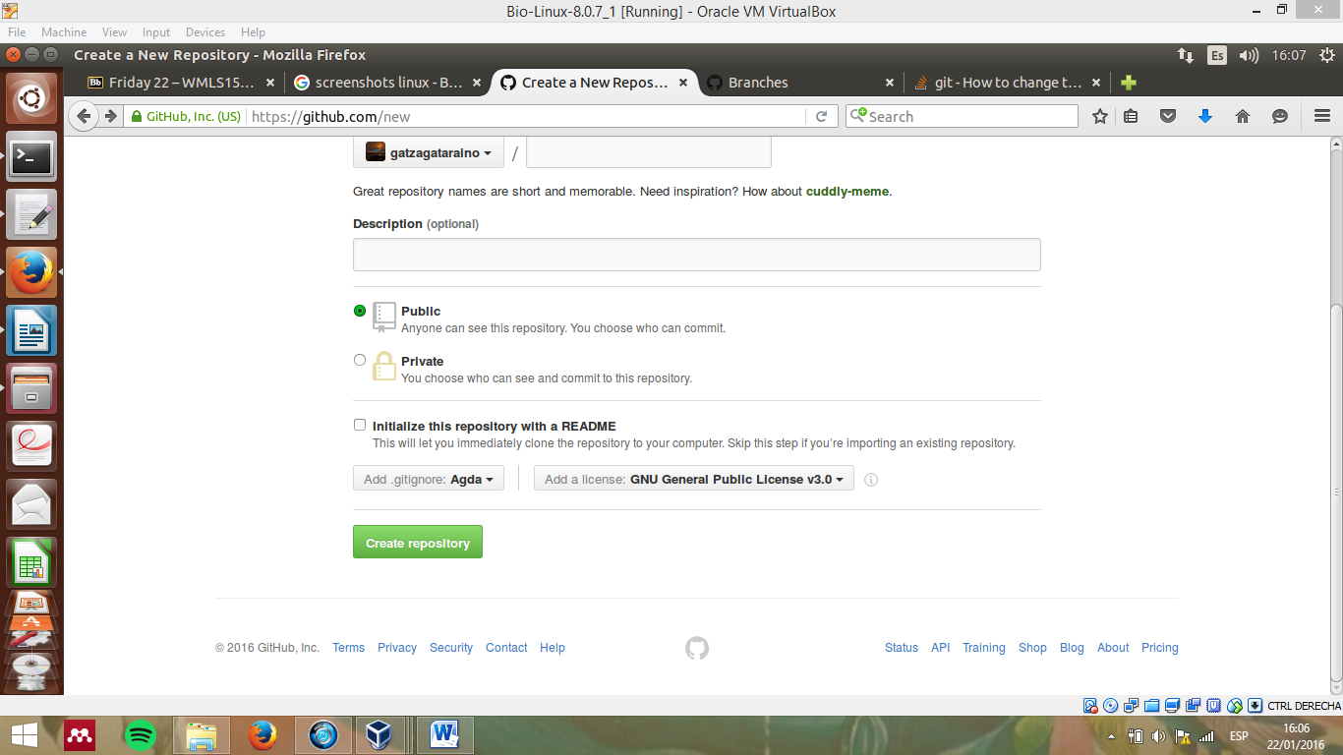

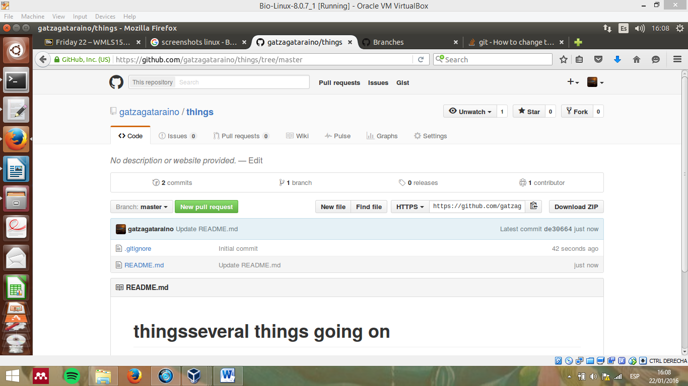

## Close issue

